DUCK LAKE
2020 Water sampling results in E-Coli/ml
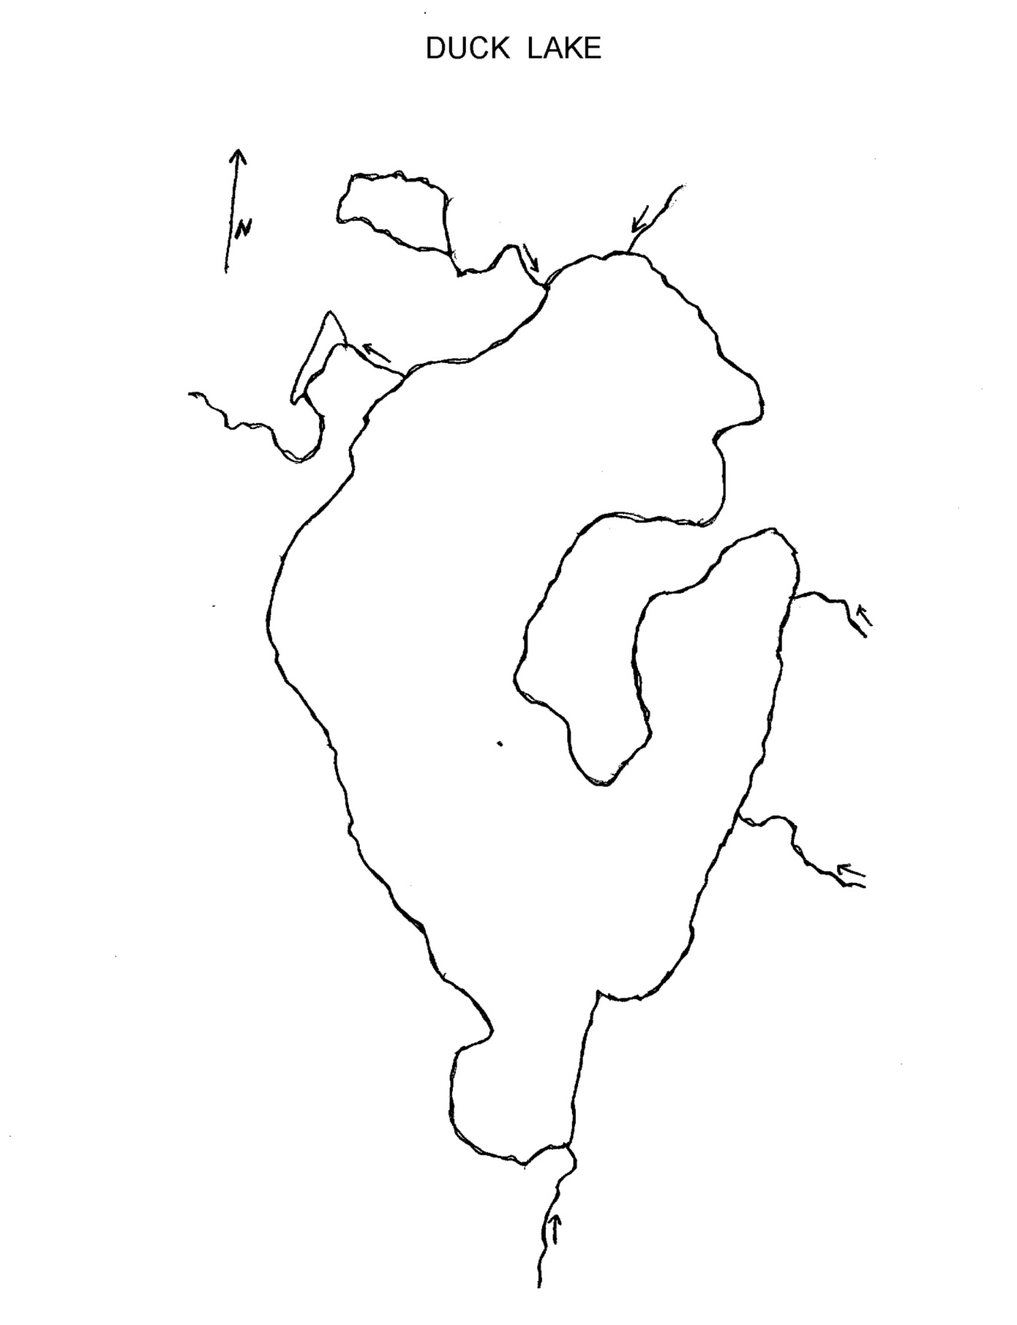
Rainbow Pond inlet – 153.9/66.7
Readings of 100 or more are retested and nearby residents notified if results remain high.
Mason Creek – 82.0
Brigham Creek – 145.5/166.4 R2.1
Burdinie Creek – 20.8
Tonawanda Creek – 55.4
State Park swim area – 3.1
Canal – 35.9
Brookside swim area – 5.2
Southwest sand bar swim area – 1.0
Interlochen swim area – nnnnNna28.8
Horton Creek -0.0
Dam Outlet – 0.0

